## **Phase 7: Integration & External Access**

This document outlines the integration steps for the ShopSmart project, detailing configurations and providing placeholders for relevant screenshots.

### **1. Named Credentials**

**Description:**  
 Named Credentials securely store authentication and endpoint information for external APIs, simplifying callouts.

**Configuration:**

* **Name:** LogisticsAPI
* **URL:** https://api.logistics.com
* **Identity Type:** Named Principal
* **Authentication Protocol:** OAuth 2.0
* **Authentication Provider:** ShopSmartAuthProvider
* **Scope:** read write

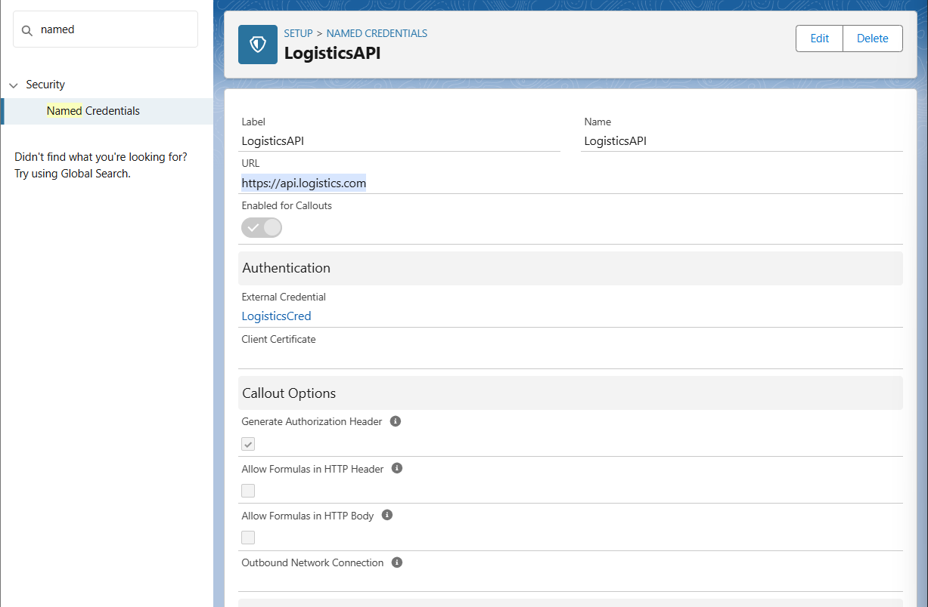

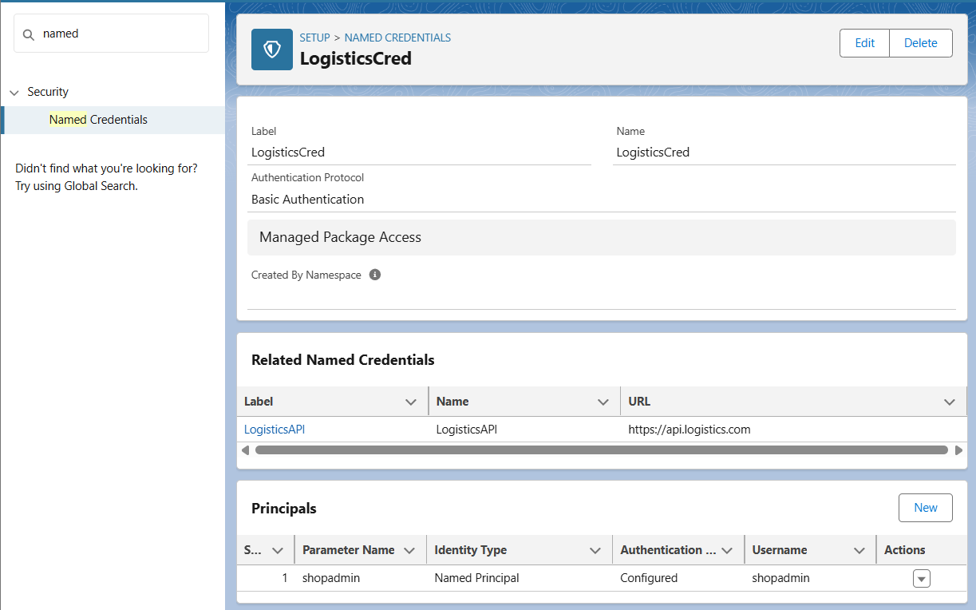

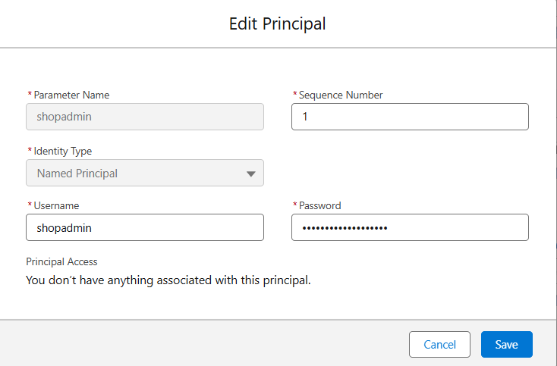

### **2. External Services**

**Description:**  
 External Services allow Salesforce to connect to external APIs by importing their OpenAPI 2.0 schemas.

**Configuration:**

* **API Schema:** Imported from <https://api.shopsmart.com/openapi.json>
* **Operations Registered: All**

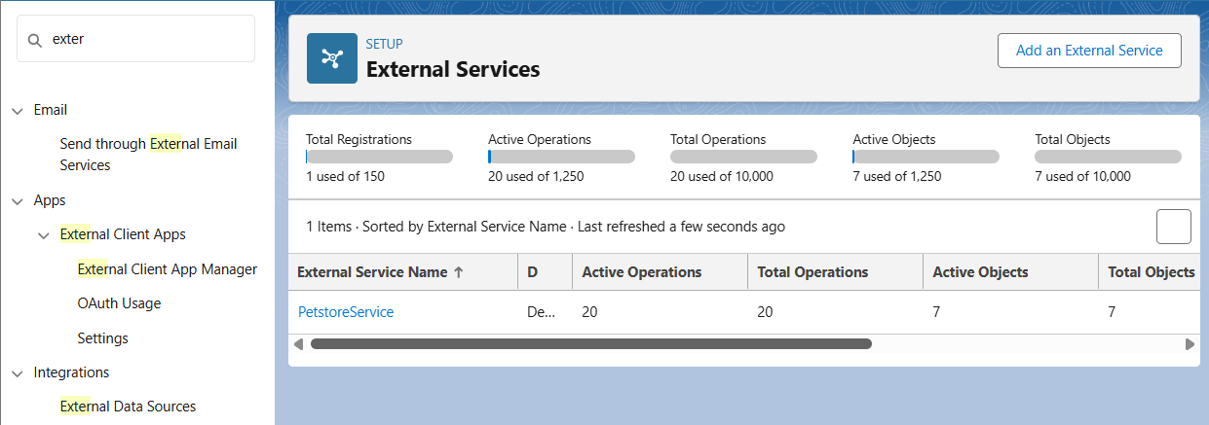

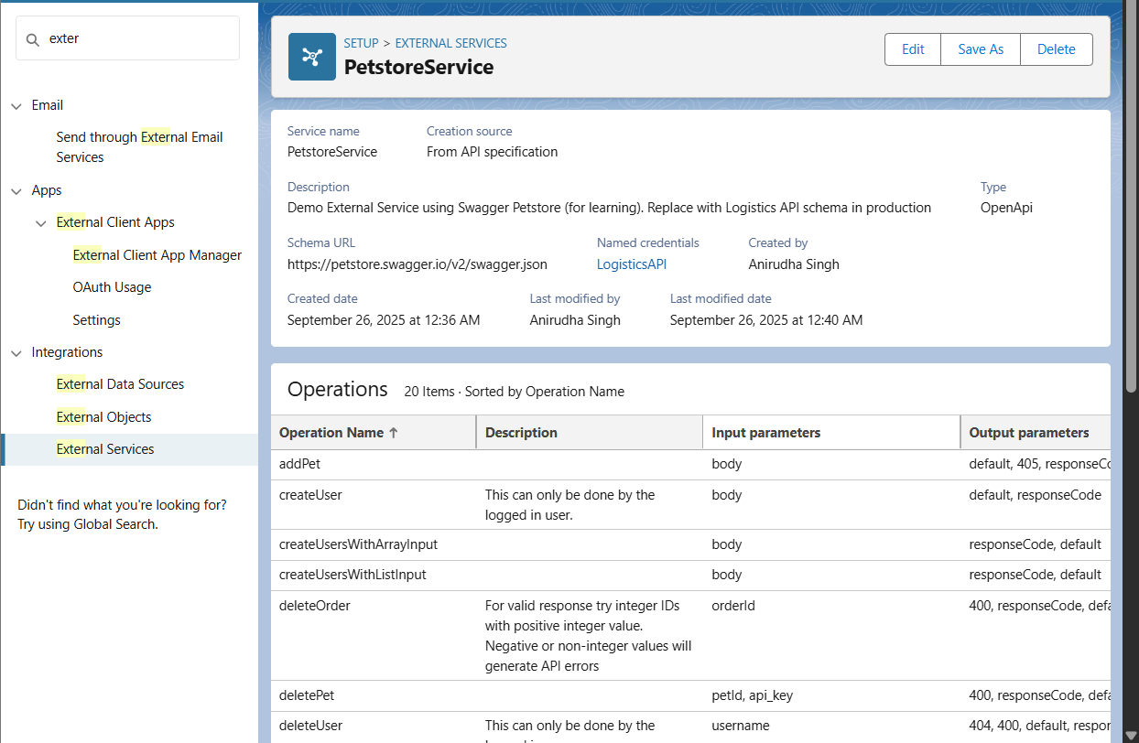

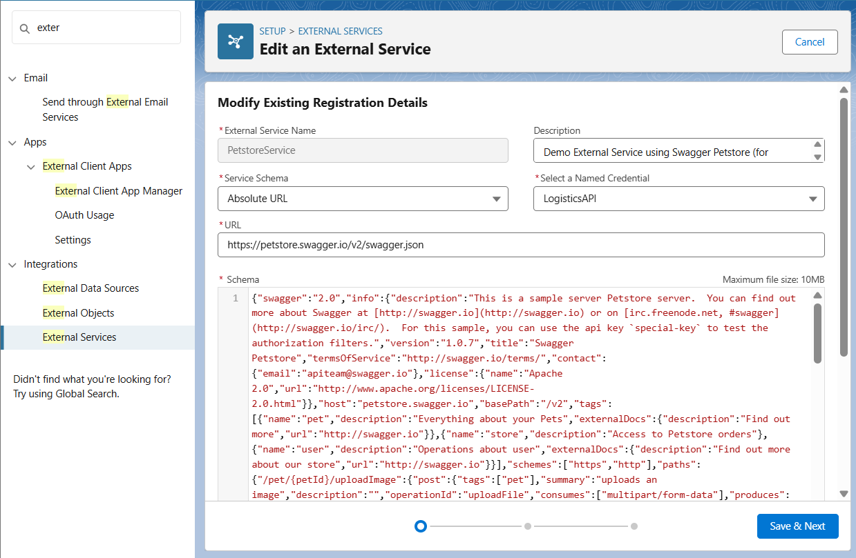

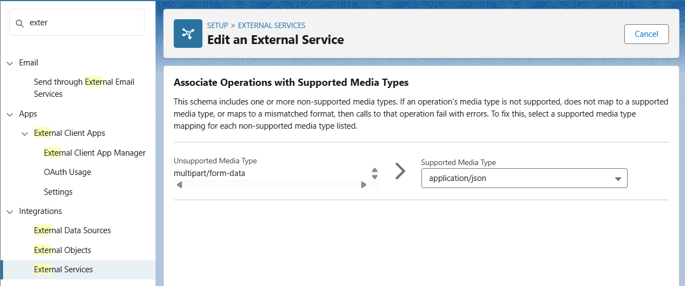

### **3. Web Services (REST/SOAP)**

**Description:**  
 Salesforce can expose its own APIs to external systems or call external APIs using REST or SOAP protocols.

**Configuration (REST Example):**

* **Apex Class:** ShopSmartREST
* **URL Mapping:** /ShopSmartOrders/*
* **HTTP Methods:** @HttpGet, @HttpPost
* **Logic:** Handles order retrieval and creation using Apex.

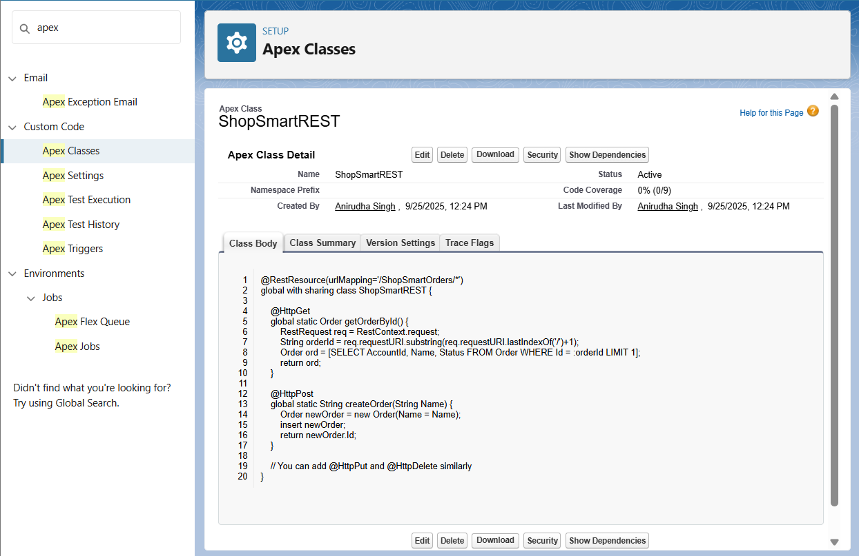

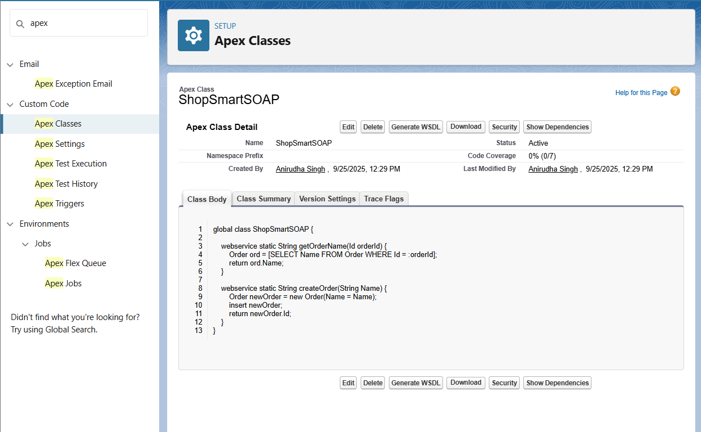

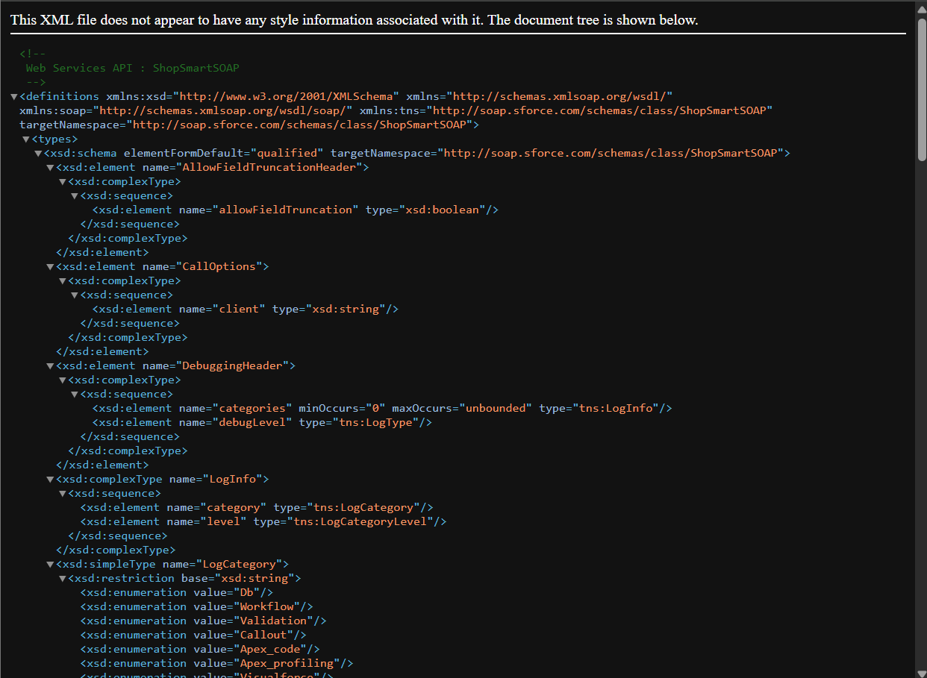

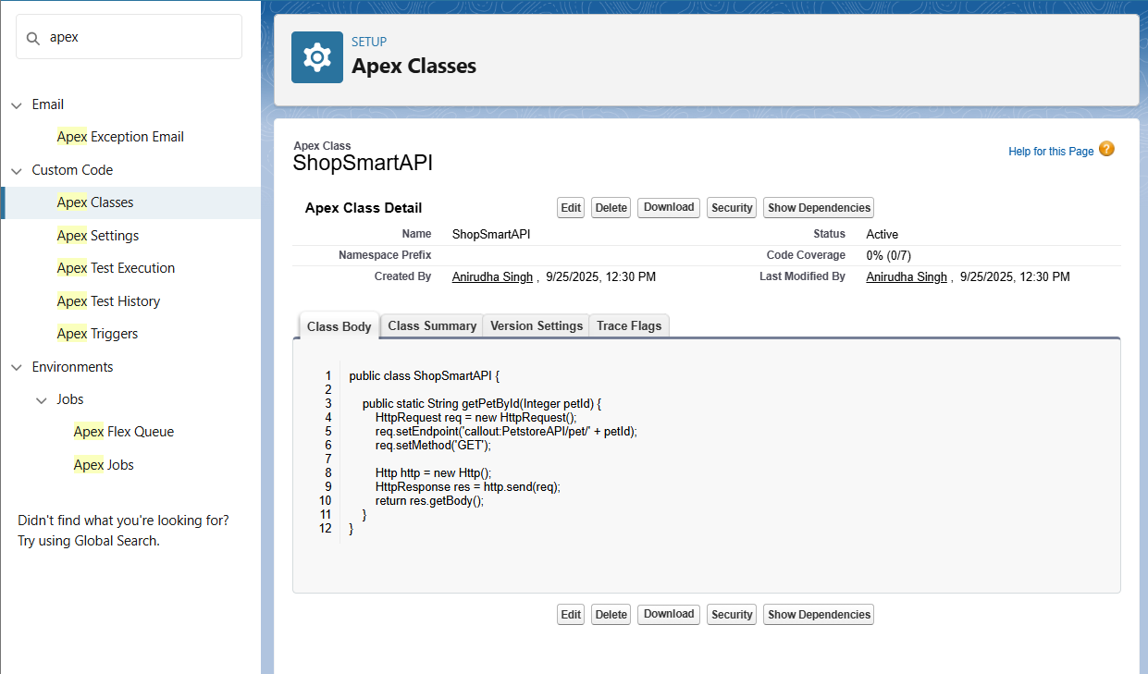

### **4. Callouts**

**Description:**  
 Apex or Flow callouts enable Salesforce to send or receive data from external APIs.

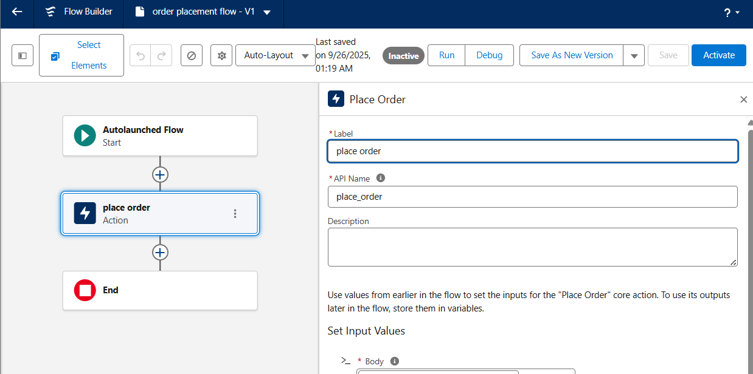

### **5. Platform Events**

**Description:**  
 Platform Events facilitate real-time communication between Salesforce and external systems.

**Configuration:**

* **Event Name:** OrderEvent__e
* **Fields:**
  + OrderId__c
  + CustomerName__c
  + Amount__c
* **Trigger:** OrderEventTrigger

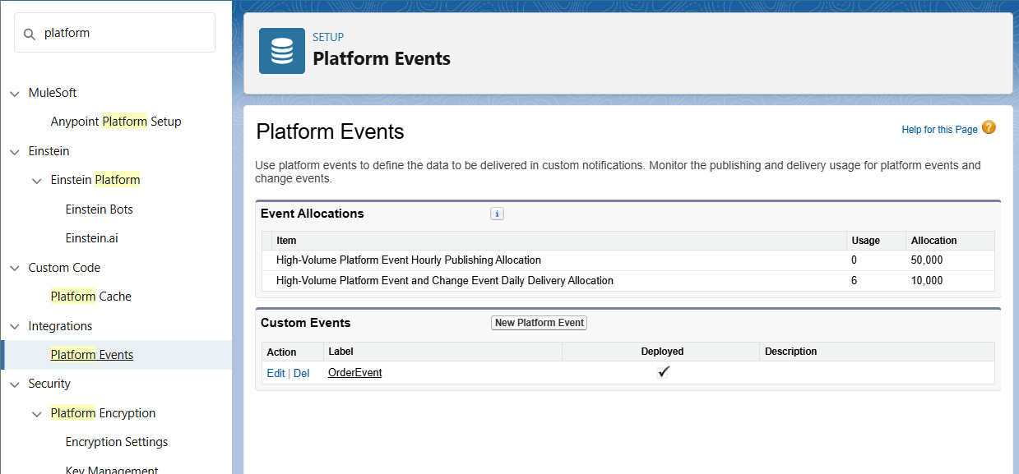

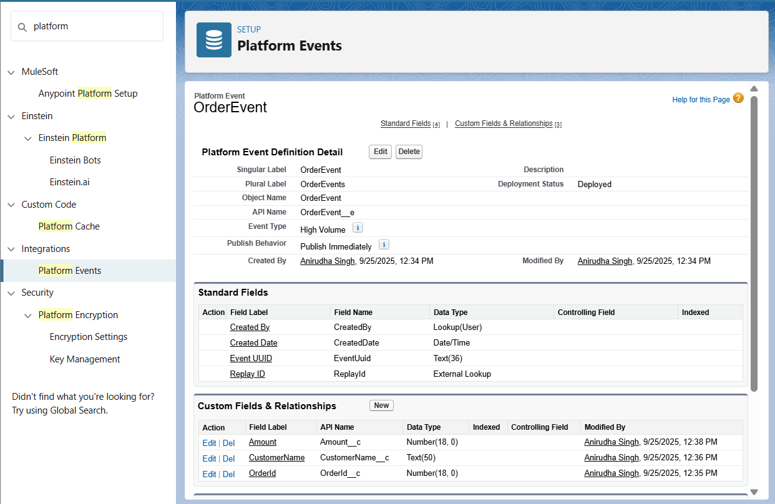

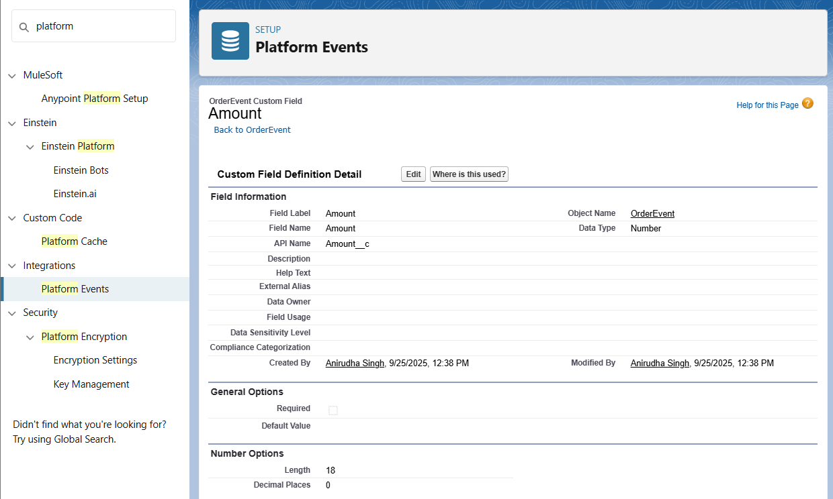

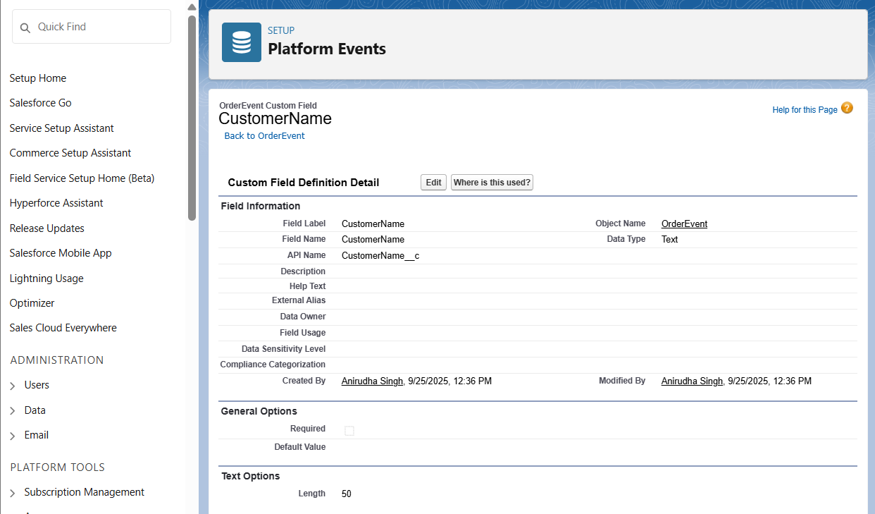

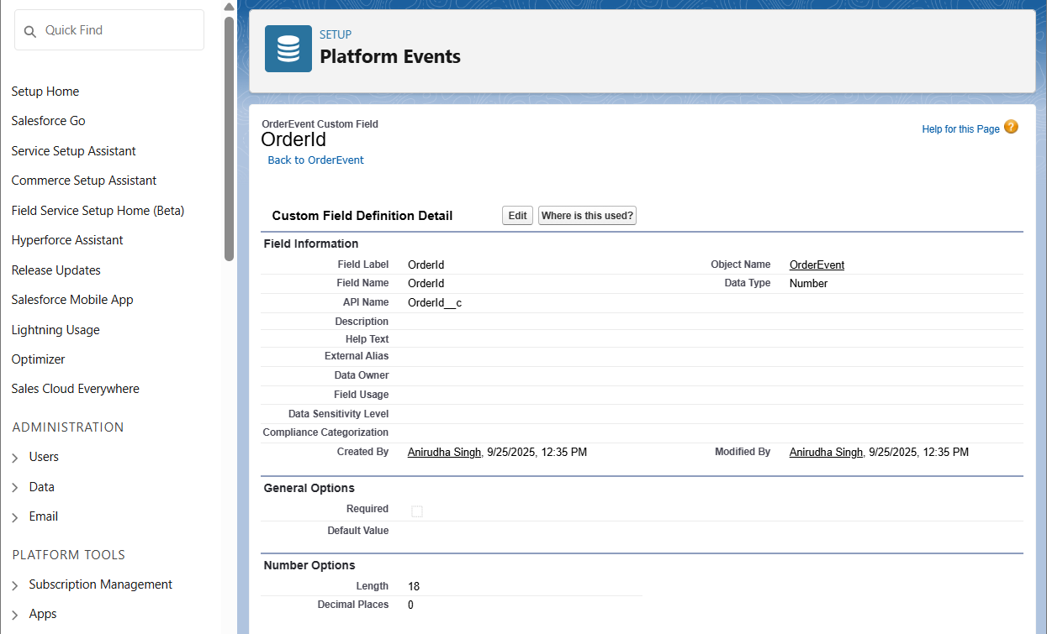

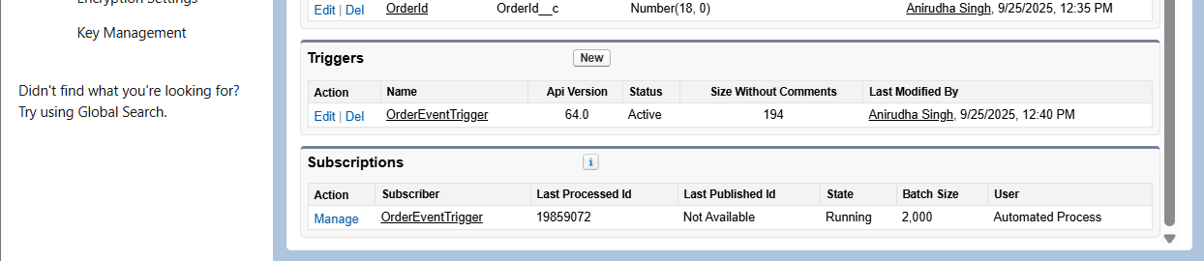

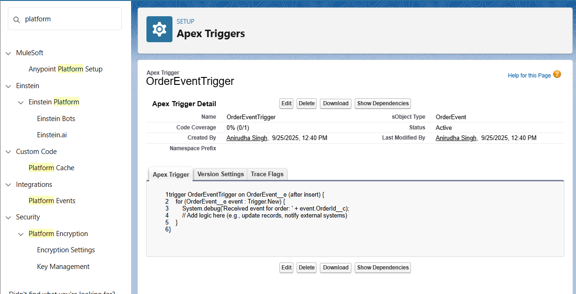

### **6. Change Data Capture**

**Description:**  
 Change Data Capture (CDC) allows Salesforce to capture changes in records and notify external systems.

**Configuration:**

* **Enabled Objects:** Order__c, Product__c,User
* **Trigger:** OrderChangeTrigger

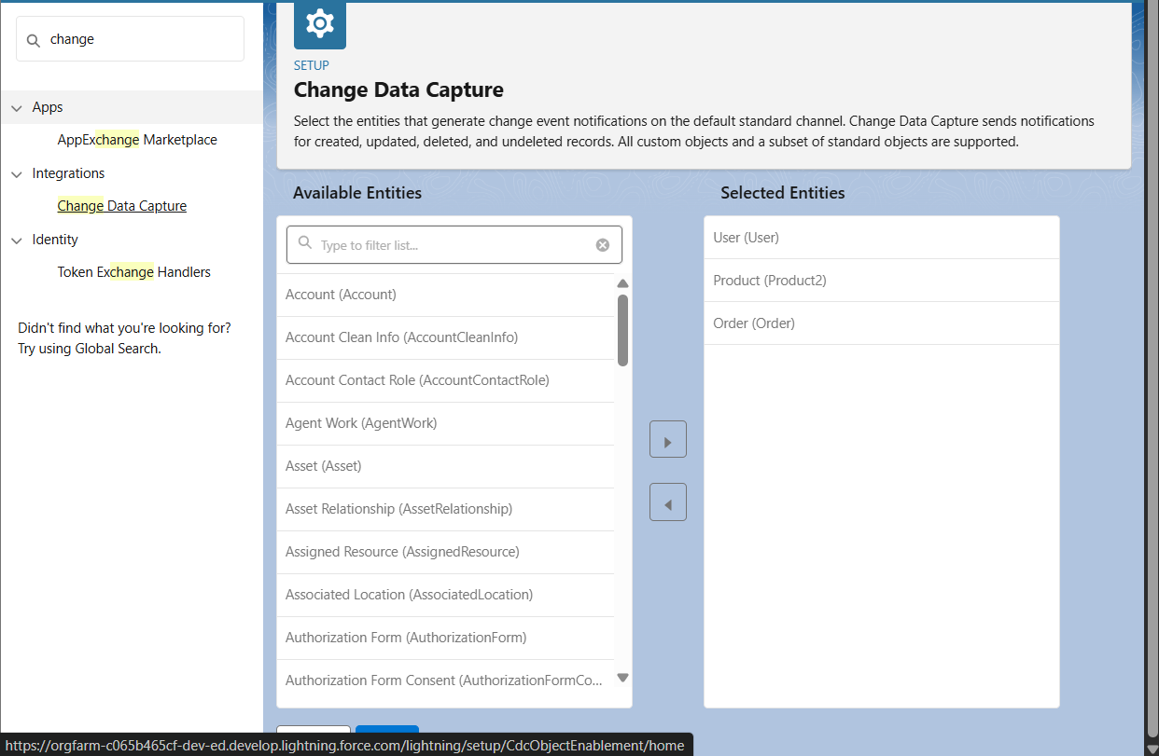

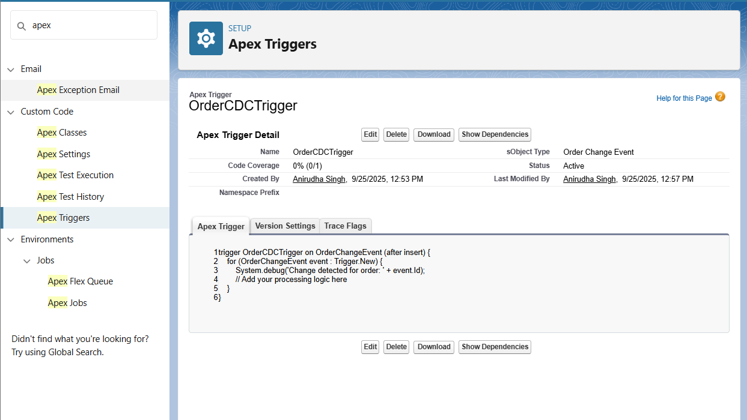

### **7. Salesforce Connect**

**Description:**  
 Salesforce Connect enables Salesforce to access and display data from external systems in real-time.

**Configuration:**

* **External Data Source:**
  + **Name:** ShopSmartAPI
  + **Type:** Salesforce Connect: OData 2.0
  + **Endpoint URL:** [**https://api.shopsmart.com/**](https://orgfarm-c065b465cf-dev-ed.develop.my.salesforce.com/servlet/servlet.ExternalRedirect?url=https%3A%2F%2Fapi.shopsmart.com%2F)
  + **Identity Type:** Anonymous
  + **Authentication Protocol:** No Authentication
* **Synced Objects:**
  + Order
  + Product
  + Customer

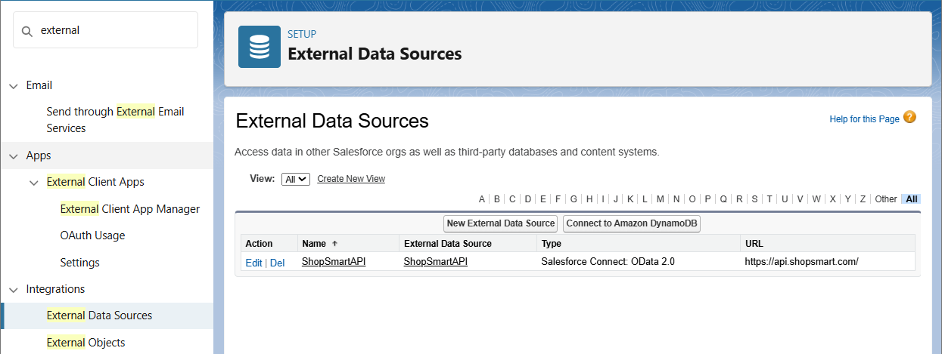

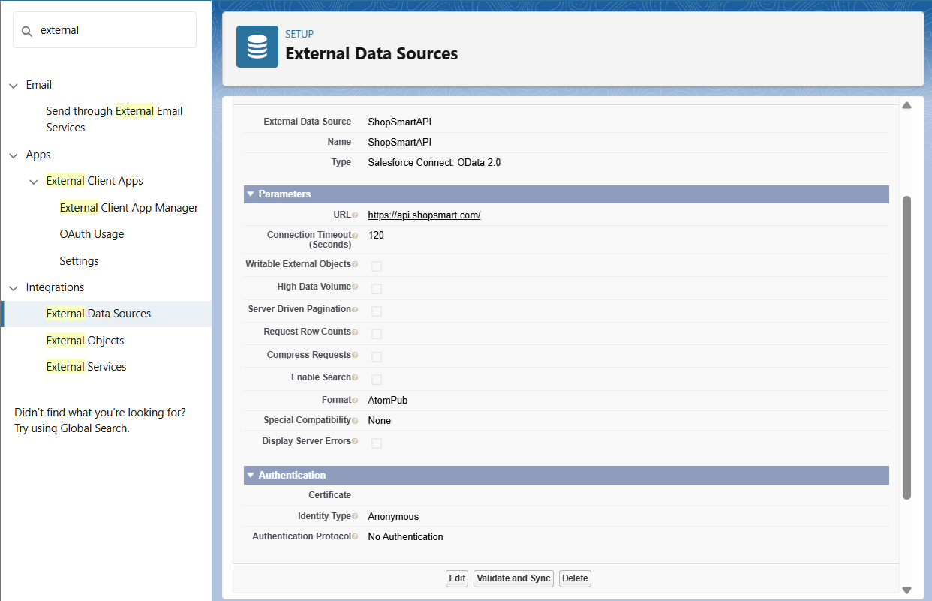

### **8. API Limits**

**Description:**  
 Salesforce imposes limits on API usage to ensure fair resource allocation and system stability.

**Configuration:**

* **API Limit Monitoring:** Regularly monitor API usage through the System Overview page.
* **Optimization:** Implement efficient coding practices to minimize API calls.

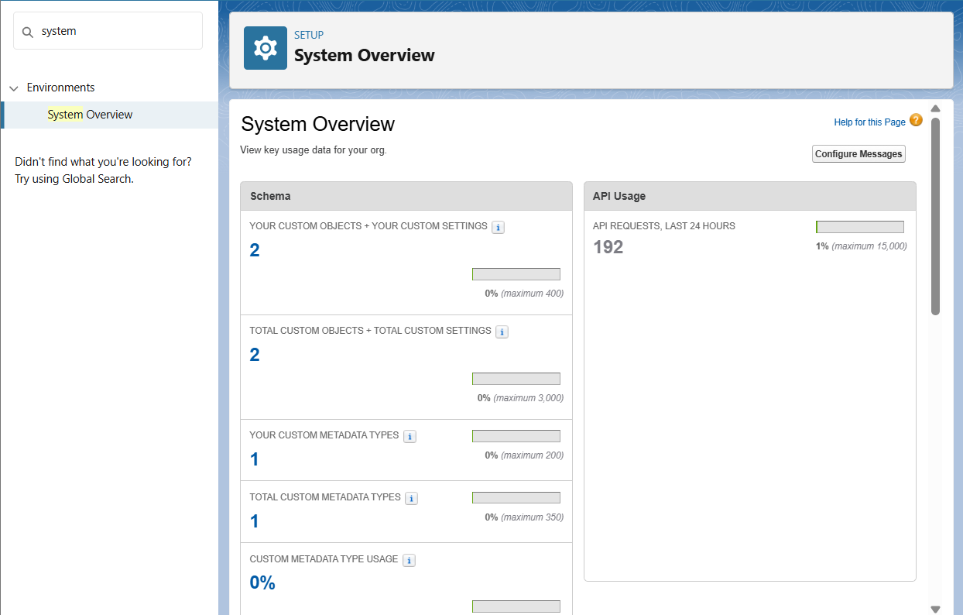

### **9. OAuth & Authentication**

**Description:**  
 OAuth 2.0 is used to authenticate and authorize third-party applications to access Salesforce data.

**Configuration:**

* Named Credentials cover authentication for external callouts.
* No extra action needed.

### **10. Remote Site Settings**

**Description:**  
 Remote Site Settings define a list of external sites that Salesforce can communicate with.

**Configuration:**

* **Remote Site Name:** ShopSmartAPI
* **Remote Site URL:** https://api.shopsmart.com
* **Active:** Checked

**Configuration:**

* **Remote Site Name:** PetstoreAPI
* **Remote Site URL:** https://petstore.swagger.io
* **Active:** Checked

